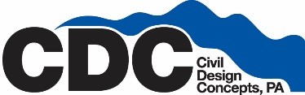

Administrative Assistant
The team at Civil Design Concepts is seeking the right person to help provide outstanding client service in a fast-paced engineering firm. Our firm is located in downtown Asheville, a vibrant, progressive city surrounded by the gorgeous mountains of Western North Carolina.
Applicants must demonstrate professionalism, dependability, healthy and positive communication skills, and the ability to multi-task.
Our next team member will be an energetic people person with excellent work ethic and social and organizational skills.
As an Administrative Assistant you will
- Receive and place calls to clients and consultants.
- Confirm and follow up on appointments.
- Greet and assist clients and consultants with excellent customer service.
- Various other duties may be assigned under the direction of Administrators or Managers.
- Assist our Project Managers with scheduling emailing and phone calls
- This position requires excellent customer service skills and an exceptional level of communication in a professional manner.
The ability to multitask and stay organized will be an essential part of your daily performance.
This position requires a large amount of public contact therefore you must be a “people person” and enjoy interacting with our clients and consultants.
Requirements
- Requires strong client service skills.
- Prior Administrative experience preferred, but not required.
- Familiarity with Microsoft Office Suite
- Ability to work independently on assigned tasks as well as to accept direction on given assignments.
- Possession of organizational skills.
Benefits
- Ownership in our Company via our Employee Stock Ownership Plan
- Health Dental and Life Insurance
- 401k
- Competitive salary, based on experience and expertise
- Be a part of a great environment with an excellent team

To Apply submit a resume on our website, www.cdcgo.com/careers

